**PCB Specification Radxa Shield Rev1.2**

* Board Layer Stackup

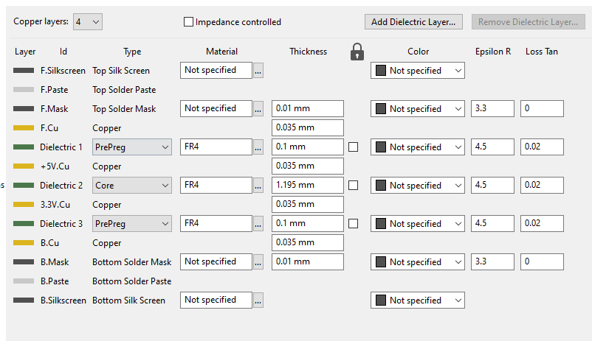

* Constraints

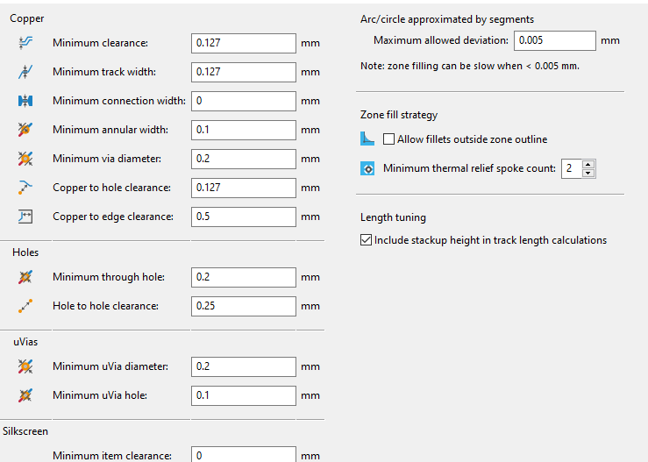

* impedance control

It’s necessary to apply 90ohm impedance control to the following USB traces on the layer5(signal2), layer8(B.Cu).

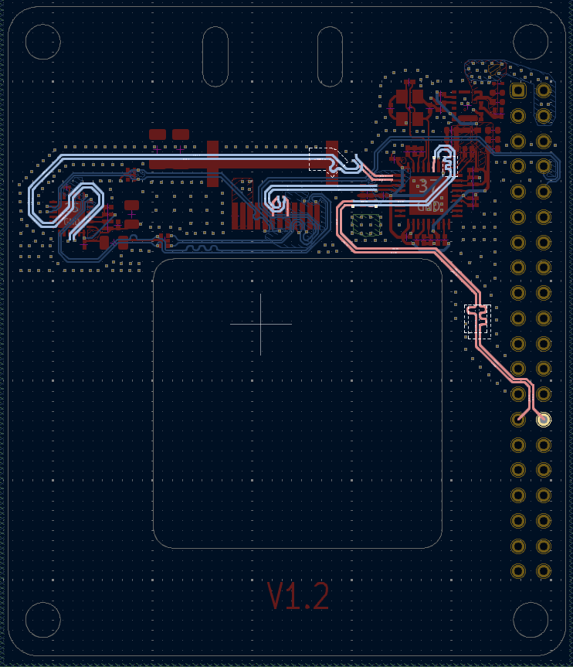

* Assembly

Pin1 indicators

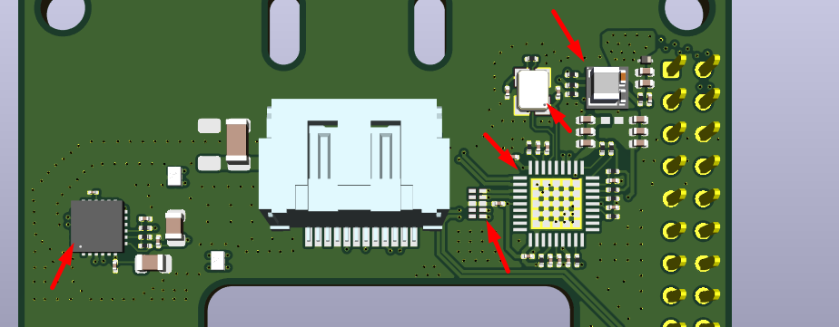

Drawings

